|  |  |
| --- | --- |
|  | Testing Plan |
|  |  |
|  | The MisSprints  ACME Movie Database  6/17/20 |

|  |  |  |  |
| --- | --- | --- | --- |
| Version | Change Date | By | Description |
| 1.0 | 8/6/2020 | Ben Royans | Updated for sprint 2 |
| 1.1 | 17/06/2020 | Catherine Burns | Updated for sprint 3 |
|  |  |  |  |

1 Introduction 1

1.1 Scope 1

1.1.1 In Scope 1

1.1.2 Out of Scope 1

1.2 Quality Objective 1

1.3 Roles and Responsibilities 2

1.3.1 Scrum Master: 2

1.3.1.1 Responsibilities 2

1.3.2 Developers 2

1.3.2.1 Responsibilities 2

2 Test Methodology 3

2.1 Overview 3

2.2 Test Levels 3

2.2.1 Use Case Testing 3

2.3 Bug Triage 3

2.3.1 Confirm new bugs 3

2.3.2 Prioritise confirmed bugs 3

2.3.3 Solve inconsistencies 3

2.3.4 Review stale/in-progress bugs 3

2.3.5 Review prioritised bugs 3

2.4 Suspension Criteria and Resumption Requirements 5

2.4.1 Suspension Criteria 5

2.4.2 Resumption Criteria 5

2.5 Test Completeness 5

2.6 Test Deliverables 5

3 Resource & Environment Needs 6

3.1 Testing Tools 6

3.2 Test Environment 6

4 Business Requirements 7

4.1 Business Requirement Identifcation 7

4.2 Requirements Traceability Matrix 7

5 Test Cases 8

5.1 Test Case Results Table 8

5.2 Test Case Screenshots 10

6 Terms/Acronyms 23

# Introduction

This document outlines the procedures, strategies and other details regarding the testing phase of the current sprint. This document will define the scope of the test process, the roles of the team and the hardware/software required.

## Scope

### In Scope

The following items will be included during the testing phase:

* Admin login functionality
  + Admin login with credentials
  + Admin gain access to privileged administrative pages
  + New admin can be created
  + Users will have access to the user web pages
* A web page that displays the top 10 popular movies
* Users are able to rate movies
* Popular movies are rated from the user ratings.
* Popular movies table will updated according to new ratings being entered.

### Out of Scope

Anything NOT outlined in the above scope section will NOT be tested.

## Quality Objective

The objective of testing this application is to ensure it satisfies all requirements (both functional and non-functional) and also meets the quality standards as defined by the client. Through rigorous testing patterns any bugs, issues and un-expected behaviour will be identified and corrected. This approach will help us to deliver a quality application as the final product that exceeds customer expectations.

## Roles and Responsibilities

### Scrum Master:

The current scrum master is Jai Anada.

#### Responsibilities

* Optimisation Report
* Update project management plan
* Client demonstration

### Developers

The current developers are Catherine Burns and Ben Royans.

#### Responsibilities

* Programming
* Software testing plan
* Develop the (analytics) web page

# Test Methodology

## Overview

This project employs the Rapid Application Development (RAD) methodology. This means testing occurs within every iteration (sprint) of the software development cycle. As this project has been structured to carry out weekly sprints, the testing will also occur as frequently.

## Test Levels

### Use Case Testing

As functionality as implemented into the website, it will be tested against it’s requirements and specifications to ensure it behaving correctly. Use case testing involves tabulating all possible course of actions for a user to achieve a desired result (such as navigate to the search page), recording the expected results and then testing them against real-world tests.

## Bug Triage

The goal of the triage is to provide framework and structure for the process of eliminating bugs or issues within the software as it is being developed.

### Confirm new bugs

Confirm the presence or absence of a newly reported bug. Attempt to re-create the bug in simulated conditions.

### Prioritise confirmed bugs

Prioritise all existing bugs based on their severity level. The chart below will provide a guide as how to classify bugs.

### Solve inconsistencies

Gather any further required information regarding an existing bug and improve understanding.

### Review stale/in-progress bugs

Review any bug fixes currently in production, prioritising those that have not any recent progression.

### Review prioritised bugs

Assess each individual bug, devising possible solutions and documenting any restrictions.

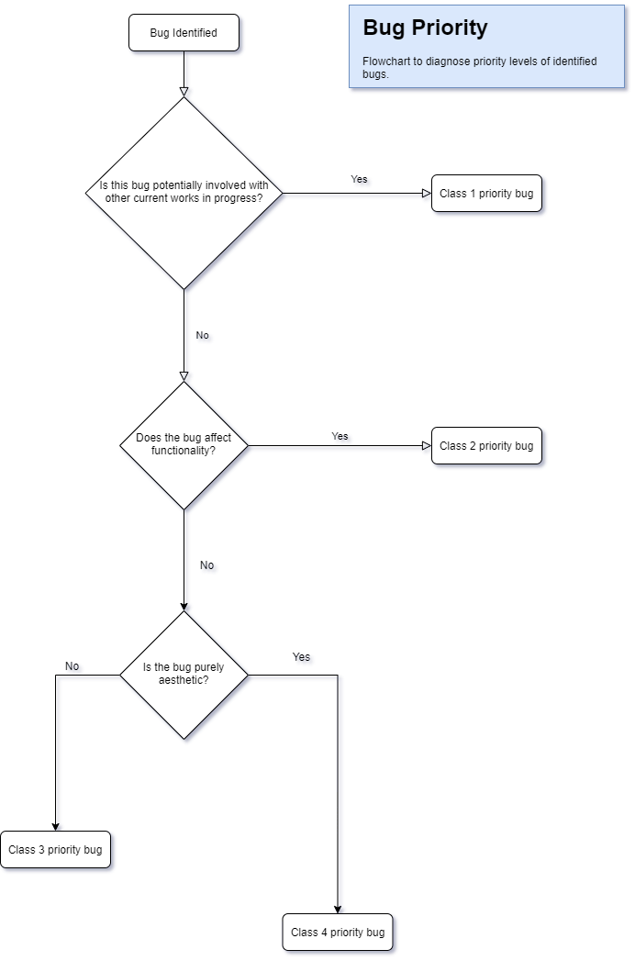

## Suspension Criteria and Resumption Requirements

The are the criteria for any disruption to the testing process and workflow.

### Suspension Criteria

Testing for a particular functoinality is to be suspended once a bug has been identified. Sub-sequential behaviour can not be deemed reliable for testing once bugged methods are used.

### Resumption Criteria

Testing for particular functionalities can be resumed once any identified bugs have been corrected by the developers.

## Test Completeness

The initial testing process will be considered completed when all methods have been carried out and all data has been recorded. The final testing process will not be considered finished until all functional and non-functional requirement tests have passed.

Bugs will not hinder the testing process providing they do not affect functionality (class 3 or higher bugs are acceptable).

## Test Deliverables

Below is a list of deliverables to be expected upon the completion of the testing process.

* Test Plan (this document)
* Test Cases
* Requirement Traceability Matrix
* Test Metrics
* Customer Sign Off

# Resource & Environment Needs

## Testing Tools

The following tools are required to test the software:

* A modern web browser (Such as Google Chrome or Mozilla Firefox)
* A text editor (Such as VS Code or Notepad++)
* A code cleaner (Such as PHPCodeSniffer)
* GitKraken GUI client (For access to Bugs/Issues board)

## Test Environment

Below outlines the minimum hardware requirements that will be used to test the Application.

* [No minimum requirements]

The test environment is required to have one of the following operating systems installed:

1. Windows XP Service Pack 2 and above
2. Android Jellybean
3. Mac OS X

# Business Requirements

## Business Requirement Identifcation

The below table defines the business requirements for the current sprint.

|  |  |
| --- | --- |
| **Code** | **Requirement Description** |
| BR1 | The website must contain a login for admin. |
| BR2 | New admin can be created. |
| BR3 | Username and password should be validated before entry. |
| BR4 | Admin has access to admin pages. |
| BR5 | Users can rate movies. |
| BR6 | Top 10 popular movies page loads the top 10 user rated movies. |
| BR7 | This Top 10 chart must update according to when users rate movies. |

## Requirements Traceability Matrix

Below is the requirements traceability matrix outlining the cases responsible for the testing of the individual business requirements.

|  |  |  |  |
| --- | --- | --- | --- |
| **Business Requirement** | **Test Case #** | **Defects** | **Status** |
| BR1 | 1 | - | Satisfied |
| BR2 | 2, 3 |  |  |
| BR3 | 4, 5, 6 | - | Satisfied |
| BR4 | 7 | - | Satisfied |
| BR5 | 8 | - | Satisfied |
| BR6 | 9 | - | Satisfied |
| BR7 | 10 | - | Satisfied |

# Test Cases

## Test Case Results Table

|  |  |  |  |  |
| --- | --- | --- | --- | --- |
| **#** | **Functionality** | **Data used / Input** | **Expected Result** | **Pass / Fail** |
| 1 | Admin Login | Webpage contains login page | Page loads with login form | PASS |
| 2 | Create Admin | Create admin with:   * Valid username and password | New admin is created. | PASS |
| 3 | Create Admin | Create admin with:   * Valid username * Invalid password | Error showing invalid password type. New admin is not created. | PASS |
| 4 | Admin Login | Login with:   * Correct admin creditals | Login is successful and admin has access to admin pages | PASS |
| 5 | Admin Login | Login with:   * Incorrect username * Correct Password | Error showing invalid username. Login does not continue. | PASS |
| 6 | Admin Login | Login with:   * Correct username * Incorrect Password | Error showing invalid password. Login does not continue. | PASS |
| 7 | Admin Login | Admin has access to:   * Movie Table * Unsubscription Requests * Add Movie * Start Auto-Scrape | Admin has access to all admin pages. | PASS |
| 8 | User | User can rate a movie | When movie is rated, the database updates. | PASS |
| 9 | Top 10 Popular Movies Page | Top 10 movies are displayed according to their user rating | Page loads with top 10 movies. | PASS |
| 10 | Top 10 Popular Movies Page | Top 10 chart changes according to any additional ratings. | Chart updates and changes occur when ratings change. | PASS |

## Test Case Screenshots

|  |  |
| --- | --- |
| **#** | **Screenshot** |
| 1 |  |
| 2 |  |
| 3 |  |
|  |  |
| 4 |  |

|  |  |
| --- | --- |
| 5 |  |

|  |  |
| --- | --- |
| 6 |  |

|  |  |
| --- | --- |
| 7 |  |

|  |  |
| --- | --- |
| 8 |  |
| 9 |  |

|  |  |
| --- | --- |
| 10 |  |

# Terms/Acronyms

| TERM/ACRONYM | DEFINITION |
| --- | --- |
| API | Application Program Interface |
| AUT | Application Under Test |
| RAD | Rapid Application Development |
| GUI | Graphical User Interface |
| RTM | Requirement Traceability Matrix |